**SHRI DATTA MEGHE POLYTECHNIC, NAGPUR**

**DEPARTMENT OF COMPUTER TECHNOLOGY**

**SESSION 2019-2020**



**Report of Micro Project for the subject Python (22616)**

On

**Student Management System**

Submitted By

#### **1. Amaan Ranapurwala 2. Aniruddha Kate**

#### **3. Dewam Katole 4. Ritvik Nimje**

Group No. 4

Sixth Semester

COMPUTER TECHNOLOGY

*Guide*

Mrs. N Wasnik

# **Program**

from tkinterimport *  
import sqlite3,sys  
  
def connection():  
try:  
 conn=sqlite3.connect("student.db")  
except:  
 print("cannot connect to the database")  
return conn   
  
  
def verifier():  
 a=b=c=d=e=f=0  
if not student_name.get():  
 t1.insert(END,"<>Student name is required<>\n")  
 a=1  
if not roll_no.get():  
 t1.insert(END,"<>Roll no is required<>\n")  
 b=1  
if not branch.get():  
 t1.insert(END,"<>Branch is required<>\n")  
 c=1  
if not phone.get():  
 t1.insert(END,"<>Phone number is requrired<>\n")  
 d=1  
if not father.get():  
 t1.insert(END,"<>Father name is required<>\n")  
 e=1  
if not address.get():  
 t1.insert(END,"<>Address is Required<>\n")  
 f=1  
if a==1 or b==1 or c==1 or d==1 or e==1 or f==1:  
return 1  
else:  
return 0  
  
  
def add_student():  
 ret=verifier()  
if ret==0:  
 conn=connection()  
 cur=conn.cursor()  
cur.execute("CREATE TABLE IF NOT EXISTS STUDENTS(NAME TEXT,ROLL_NO INTEGER,BRANCH TEXT,PHONE_NO INTEGER,FATHER TEXT,ADDRESS TEXT)")  
cur.execute("insert into STUDENTS values(?,?,?,?,?,?)",(student_name.get(),int(roll_no.get()),branch.get(),int(phone.get()),father.get(),address.get()))  
conn.commit()  
conn.close()  
 t1.insert(END,"ADDED SUCCESSFULLY\n")  
  
  
def view_student():  
 conn=connection()  
 cur=conn.cursor()  
cur.execute("select * from STUDENTS")  
 data=cur.fetchall()  
conn.close()  
for iin data:  
 t1.insert(END,str(i)+"\n")  
  
  
def delete_student():  
 ret=verifier()  
if ret==0:  
 conn=connection()  
 cur=conn.cursor()  
cur.execute("DELETE FROM STUDENTS WHERE ROLL_NO=?",(int(roll_no.get()),))  
conn.commit()  
conn.close()  
 t1.insert(END,"SUCCESSFULLY DELETED THE USER\n")  
  
def update_student():  
 ret=verifier()  
if ret==0:  
 conn=connection()  
 cur=conn.cursor()  
cur.execute("UPDATE STUDENTS SET NAME=?,ROLL_NO=?,BRANCH=?,PHONE_NO=?,FATHER=?,ADDRESS=? where ROLL_NO=?",(student_name.get(),int(roll_no.get()),branch.get(),int(phone.get()),father.get(),address.get(),int(roll_no.get())))  
conn.commit()  
conn.close()  
 t1.insert(END,"UPDATED SUCCESSFULLY\n")  
  
  
def clse():  
sys.exit()   
  
  
if __name__=="__main__":  
 root=Tk()  
root.title("Student Management System")  
  
student_name=StringVar()  
roll_no=StringVar()  
 branch=StringVar()  
 phone=StringVar()  
 father=StringVar()  
 address=StringVar()  
  
 label1=Label(root,text="Student name:")  
 label1.place(x=0,y=0)  
  
 label2=Label(root,text="Roll no:")  
 label2.place(x=0,y=30)  
  
 label3=Label(root,text="Branch:")  
 label3.place(x=0,y=60)  
  
 label4=Label(root,text="Phone Number:")  
 label4.place(x=0,y=90)  
  
 label5=Label(root,text="Father Name:")  
 label5.place(x=0,y=120)  
  
 label6=Label(root,text="Address:")  
 label6.place(x=0,y=150)  
  
 e1=Entry(root,textvariable=student_name)  
 e1.place(x=100,y=0)  
  
 e2=Entry(root,textvariable=roll_no)  
 e2.place(x=100,y=30)  
  
 e3=Entry(root,textvariable=branch)  
 e3.place(x=100,y=60)  
  
 e4=Entry(root,textvariable=phone)  
 e4.place(x=100,y=90)  
  
 e5=Entry(root,textvariable=father)  
 e5.place(x=100,y=120)  
  
 e6=Entry(root,textvariable=address)  
 e6.place(x=100,y=150)  
  
 t1=Text(root,width=80,height=20)  
 t1.grid(row=10,column=1)  
  
  
  
 b1=Button(root,text="ADD STUDENT",command=add_student,width=40)  
 b1.grid(row=11,column=0)  
  
 b2=Button(root,text="VIEW ALL STUDENTS",command=view_student,width=40)  
 b2.grid(row=12,column=0)  
  
 b3=Button(root,text="DELETE STUDENT",command=delete_student,width=40)  
 b3.grid(row=13,column=0)  
  
 b4=Button(root,text="UPDATE INFO",command=update_student,width=40)  
 b4.grid(row=14,column=0)  
  
 b5=Button(root,text="CLOSE",command=clse,width=40)  
 b5.grid(row=15,column=0)  
  
  
root.mainloop()

# **Output:-**

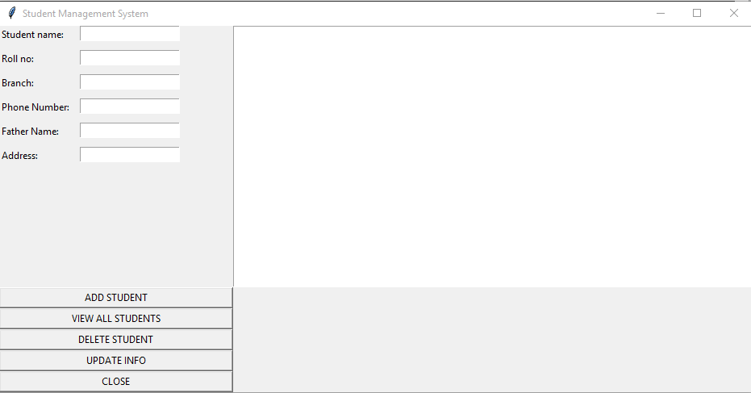

Fig.1) UI

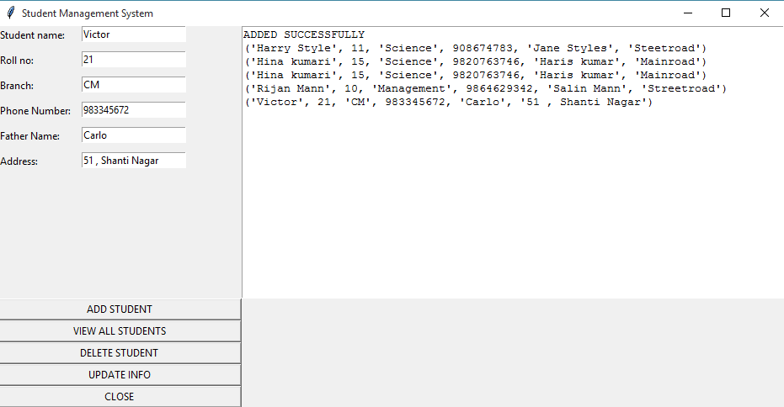

Fig.2) Adding Student Details

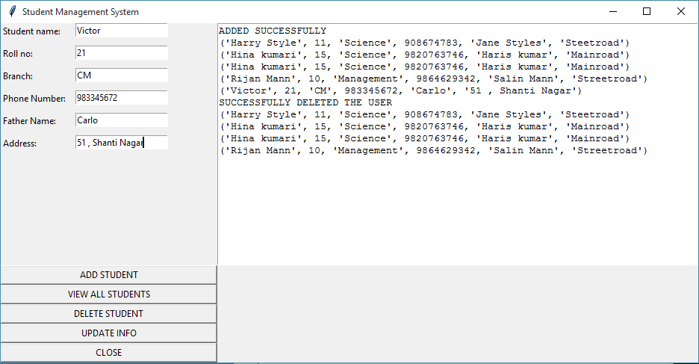

Fig.3) Deleting Student Details